Sudhir Roadlines (KMT)

This Application used for upload the new Way Bill in Ticketing machine & collecting data from Ticketing machine and then this data uploaded into the DataBase.
When we start application this screen will be shown.

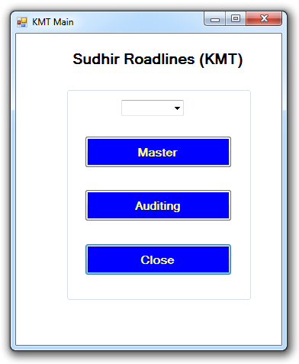

In this screen three button will be available master, auditing & close.

Master : it is used for uploading waybill into machine .

Auditing : it is used for retrieve waybill & Tickets data from machine to the application and save into DataBase Successfully.

Close : it is used for closing the application.

Master :

When you click on the Master button then new screen will be open it show in below.

First you can select the serial port number, means name of the port yours machine will be connected in my case COM3 its my serial port.
Then you can copy the generated way bill number and paste into Waybill text box and click on the right hand side button name is Get WayBill.

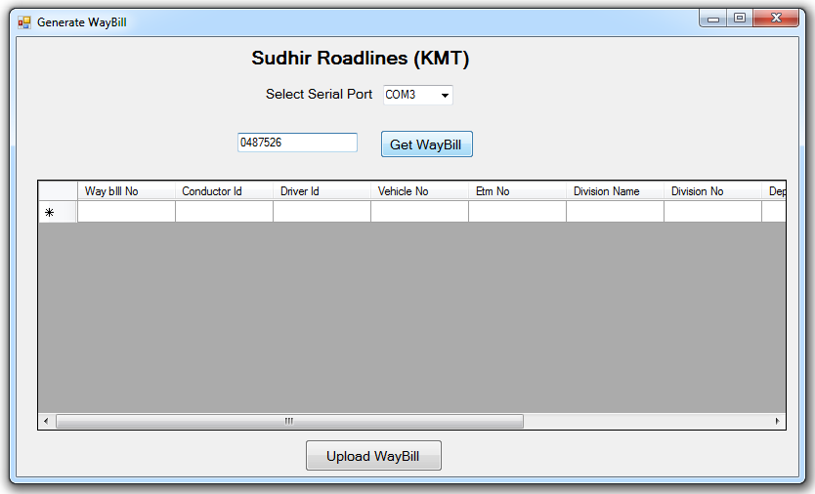
Enter
WayBill
Number
Click Here

Click : WayBill

When you click on the Get WayBill button show the all details about this waybill as show in below.

This all detail come from Database table tbl_waybill_mst. This table stored all information about waybill.

Check all detail about the waybill it show in table if its right then it will be ready to upload into the machine.
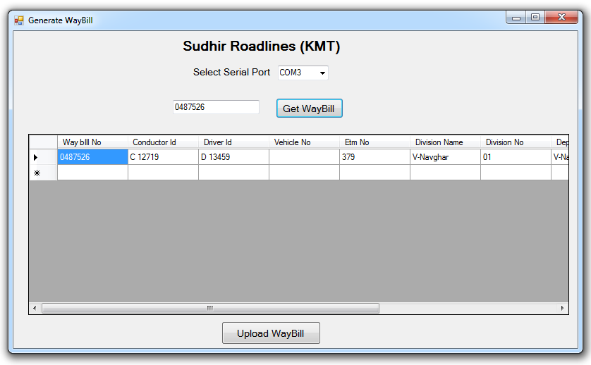
Click Here

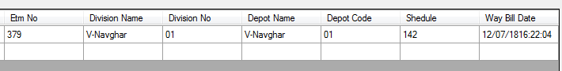

Click : Upload WayBill

Then click on the Upload WayBill button then waybill can be uploaded into machine and it uploaded then pop up will be come “Process Completed Successfully” press it ok and check the waybill on machine.

We can send the string to the machine for sending waybill. String content 105 character.

$A0487526C 2719 D 13459 V-Navghar01V-NavgharV-Navghar 01142 37912/07/1816:22:0400.15

DETAILS(105 CHAR)

$ - (CHAR 01) START CHAR
A - (CHAR 01) WAYBILL STRING CHAR
0487526 - (CHAR 06) WAYBILL NO
C 2719 - (CHAR 10) CONDUCTOR DETAILS
D 13459 - (CHAR 10) DRIVER DETAILS
MP09E4321 - (CHAR 10) VEHICLE NO.
V-Navghar ` - (CHAR 09) DIV. NAME
01 - (CHAR 02) DIV. NO
V-Navghar - (CHAR 09) DEPOT NAME
V-Navghar - (CHAR 15) DEPOT NAME / in Marathi
01 - (CHAR 02) DEPOT NO
142 - (CHAR 04) SCHEDULE NO.
379 - (CHAR 03) ETIM NO
12/07/18 - (CHAR 08) DATE
16:22:04 - (CHAR 08) TIME
00.15 - (CHAR 05) ADHIBHAR AMT.
- (CHAR 01) STRING END MARK

Auditing :

When you click on the Auditing button then new screen will be open it show in below.

It is a very important screen in that all data from the machine will shown and uploaded into Database.

First you can select the serial port number, means name of the port yours machine will be connected in my case COM3 its my serial port.

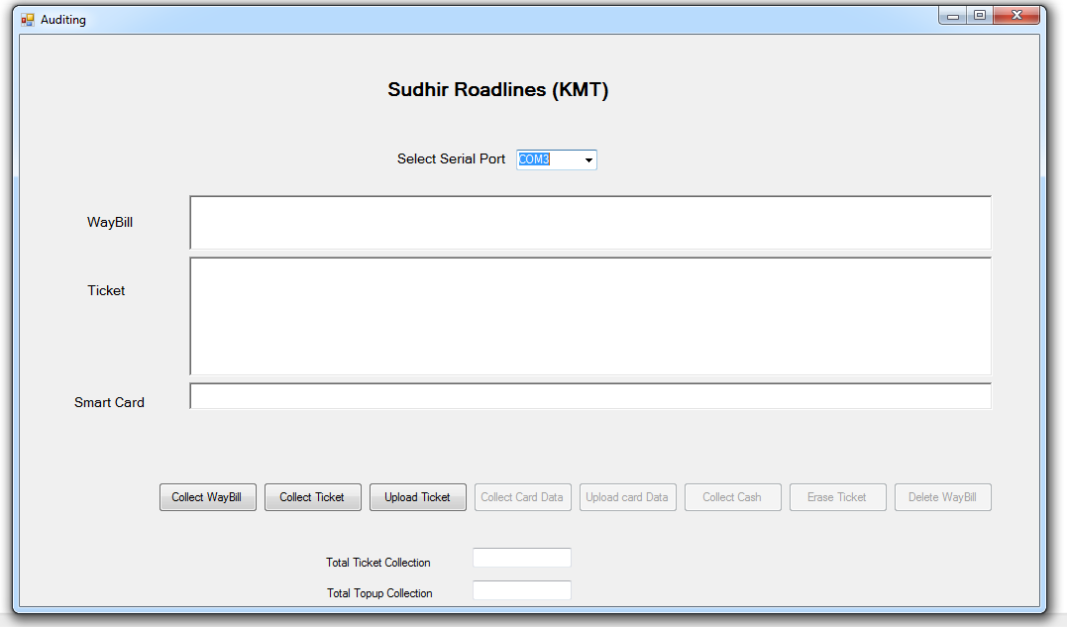
1 - Click
2 - click
3 - Click
Serial Port

- Click : Collect WayBill

When you click on the Collect WayBill button then all machine waybill information can be download form machine and shown in waybill text box , It include all the information about Driver, Conductor, vehicle Number and so on.

Machine can send a waybill detail as string :

0487526C 12719 D 13459 V-Navghar01V-Navghar01142 564MARATI BUS TKT 2013 BALAJI 12/07/1816:22:04

DETAILS(110 CHAR)

$ - (CHAR 01) START CHAR
A - (CHAR 01) WAYBILL STRING CHAR
0487526 - (CHAR 06) WAYBILL NO
C 2719 - (CHAR 10) CONDUCTOR DETAILS
D 13459 - (CHAR 10) DRIVER DETAILS
MP09E4321 - (CHAR 10) VEHICLE NO.
V-Navghar ` - (CHAR 09) DIV. NAME
01 - (CHAR 02) DIV. NO
V-Navghar - (CHAR 09) DEPOT NAME
V-Navghar - (CHAR 15) DEPOT NAME / in Marathi
01 - (CHAR 02) DEPOT NO
142 - (CHAR 04) SCHEDULE NO.
564 - (CHAR 03) ETIM NO
MARATI BUS TKT 2013 BALAJI - (CHAR 15)MACHIN NAME
12/07/18 - (CHAR 08) DATE
16:22:04 - (CHAR 08) TIME
00.15 - (CHAR 05) ADHIBHAR AMT.
- (CHAR 01) STRING END MARK

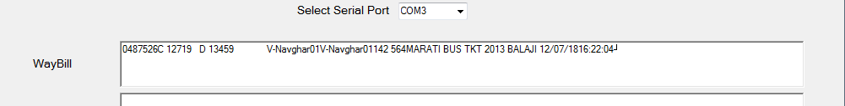
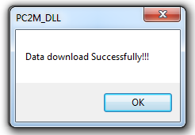

- Click : Collect Ticket

When you click on the Collect Button then all machine Tickets information can be download from machine and shown in Ticket text box, It include all the information about Tickets like time, date, amount, waybill no, ticket count and so on.

Machine can send a ticket detail as a string :

0487526 01 114 00000020 001 002 01 00 00 00 0000700 12/07/18 16:25:15 00 0 0000700 0000000 C 12719 564

DETAILS(118 CHAR)

0487526 - (CHAR 06) WAYBILL NO
01 - (CHAR 02) DIV. NO
.
0000700 -(CHAR 08) ADHIBHAR AMT.
12/07/18 - (CHAR 08) DATE
16:22:04 - (CHAR 08) TIME
MARATI BUS TKT 2013 BALAJI - (CHAR 15)MACHIN NAME
C 2719 - (CHAR 10) CONDUCTOR DETAILS
564 - (CHAR 03) ETIM NO
- (CHAR 01) STRING END MARK

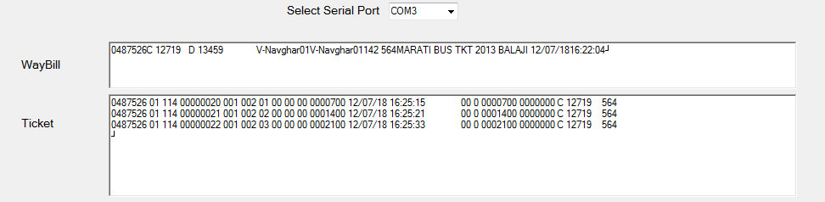
WayBill Text Box
Ticket Text Box

Total Ticket Collection : It is total amount of ticket collection in a Rs. It’s directly come from a Ticket machine.

Total Collection : It is a total Ticket Collection & total top up collection both total collection amount in a Rs.

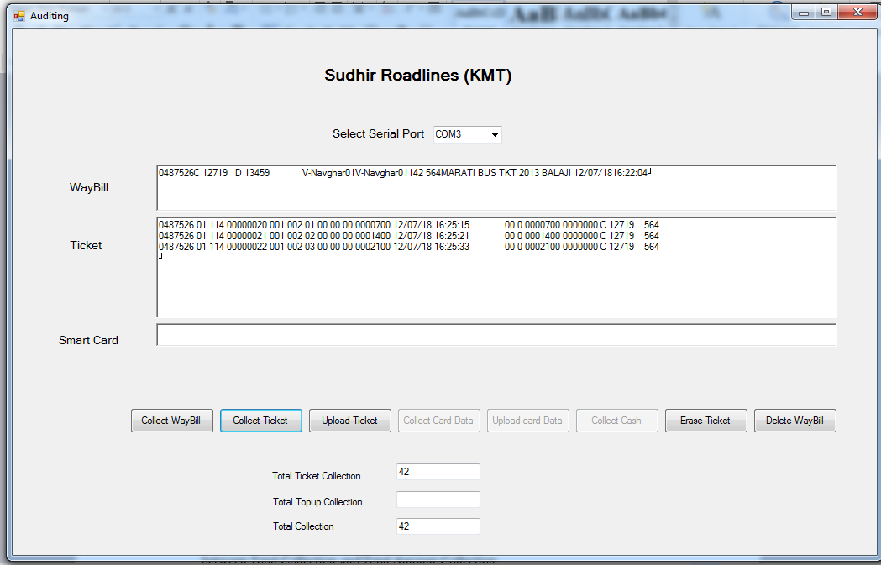

- Click : Upload Ticket

When you click on Upload Ticket then all data waybill & Tickets data upload into the given mysql database table tbl_waybill_ticket_handheld_data_dummy. It will store successfully then message will be come “Ticket Uploaded Successfully” then press ok.

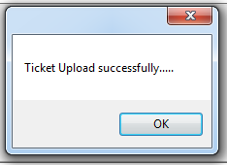

Then automatically open the Collect Cash screen.

First you can select the serial port number, means name of the port yours machine will be connected in my case COM3 its my serial port.

Collection Cash it is entry of the amount of cash collected by a conductor, means we can separate entry by specific amount of note & no of note collected by conductor.

Collection Date : Date of collection

Total Collection : It is a total amount of collection in a Rs. Its comes from a ticket machine.

Total Amount Collection : It is a total amount of collection in rs collect by the conductor

Difference: Missing amount collected by the conductor

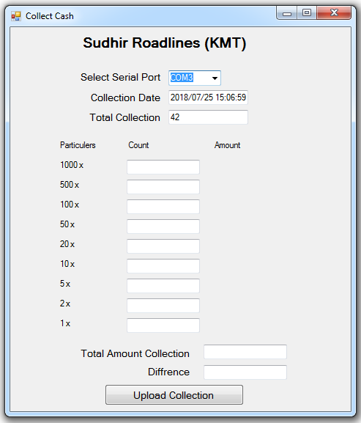

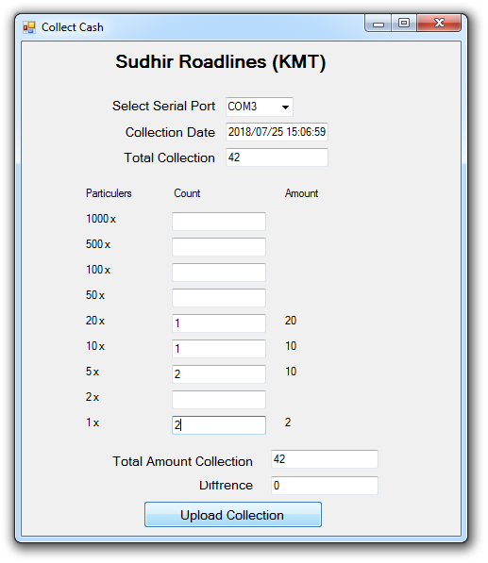
Click Here

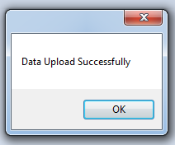

Click : Upload Collection

When you click on upload collection button all data save into to database table tbl_conductor_collection_amount. Message "Data Upload Successfully" means data was uploaded successfully in database.

Click : Erase Ticket

Delete all Tickets in the machine and blank the ticket text box as well as Total collection will be empty.

Click : Erase WebBill

Delete all WayBill in the machine and blank the waybill text box.

DataBase Changes

- Changes in the DATABASE

-- Add one columns

Table Name : tbl_conductor_collection_amount
Column Name : fldv_amount_difference
Type : Varchar(25)
Null : Yes
Default Value : Null

Add tbl_conductor_collection_amount this column used for difference between Total Collection and Total Amount Collection.

- Adding the one file in exe path folder name is KnownFile.txt this file includes the database string like

192.168.1.253;db_vvmt_ticketing;root;mysql@123;
ServerName;DatabaseName;UserName;PassWord;

For your given Mysql connections.

